

|  |  |  |
| --- | --- | --- |
| Mathematics Department | |  |
| Course: A2MAA | |
| Topic Title: Test 2 Calculator Free | |
| Student Name:_____________________________________ | Date: ____________ | | |
| Special Instructions: Formula Sheet allowed and no calculators | Time Allowed: 50 minutes | | |
| **Show all working clearly** | Marks: / 50 | | |

**Question 1. [2,2,2,3:9 marks]**

Solve following

a) $5x-8=42$ b) $4x-3=2x-11$

c) $28x-6\left(3x-5\right)=40$ d) $\frac{x+5}{3}=(2x+5)$

**Question 2. [2,2,2:6 marks]**

Determine equations of the straight lines shown below

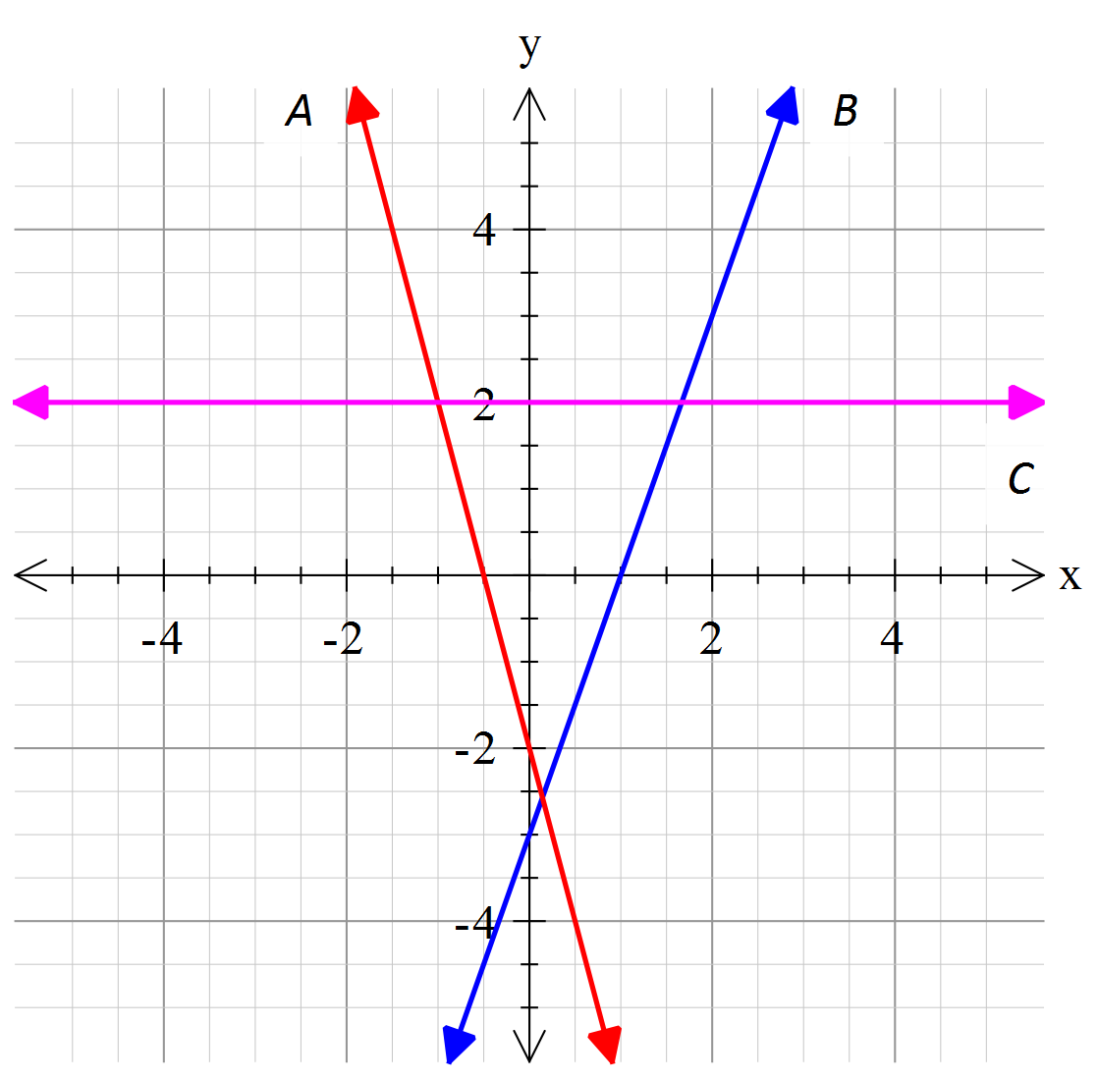

A = ________________________

B = ________________________

C = ________________________

**Question 3. [3 marks]**

I think of a number, double it, reduce it by 7 and divide it by 3. The result is 17.

What is the number?

**Question 4. [4,2,6:12 marks]**

a) Determine the equation of the straight lines with the following properties:

(i) Has a gradient of -3 and y-intercept of 4. (ii) Has a gradient of 5 and y-intercept of -1.

b) Determine the equation of the straight line that has a gradient of -2 and passes through the point (0,5)

c) Determine the gradient and y-intercept for each of these lines

(i) $y=3x-2$ (ii) $y-12=-2x$ (iii) $2y=-6x+4$

**Question 5. [4 marks]**

Graph the following functions

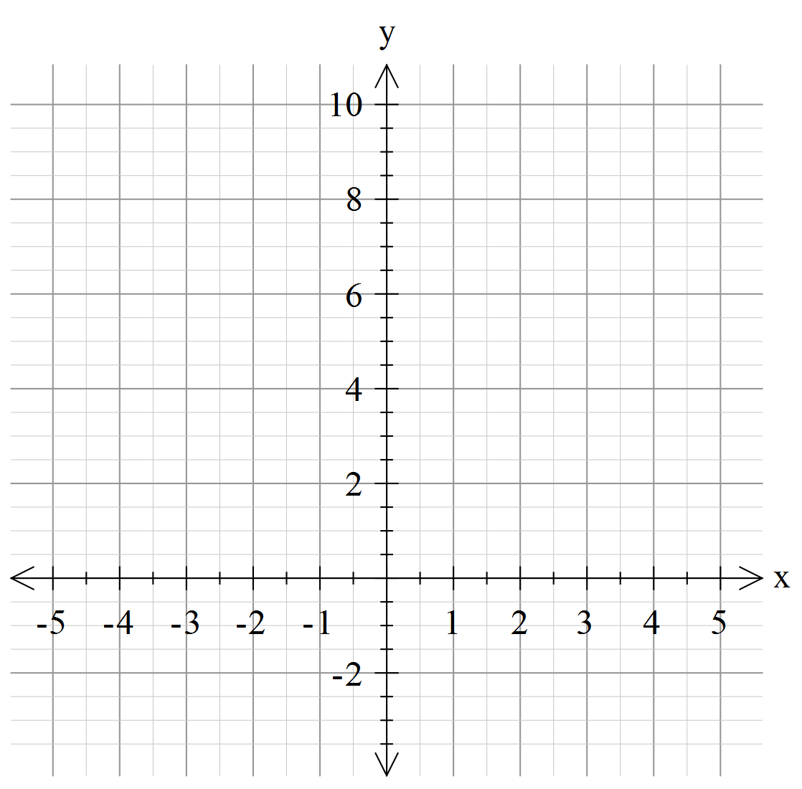

a)

$y=\left\{\begin{aligned}8, &-4<x≤-1 \\ -1, &-1<x≤0 \\ 2, 0<x≤3 \\ 4, 3<x≤4\end{aligned}\right.$

**Question 6. [3 marks]**

A wedding singer charges $200 plus $60 an hour for her services. Construct a linear graph to

show the cost ( *C* ) of the singer for ( *h* ) hours.

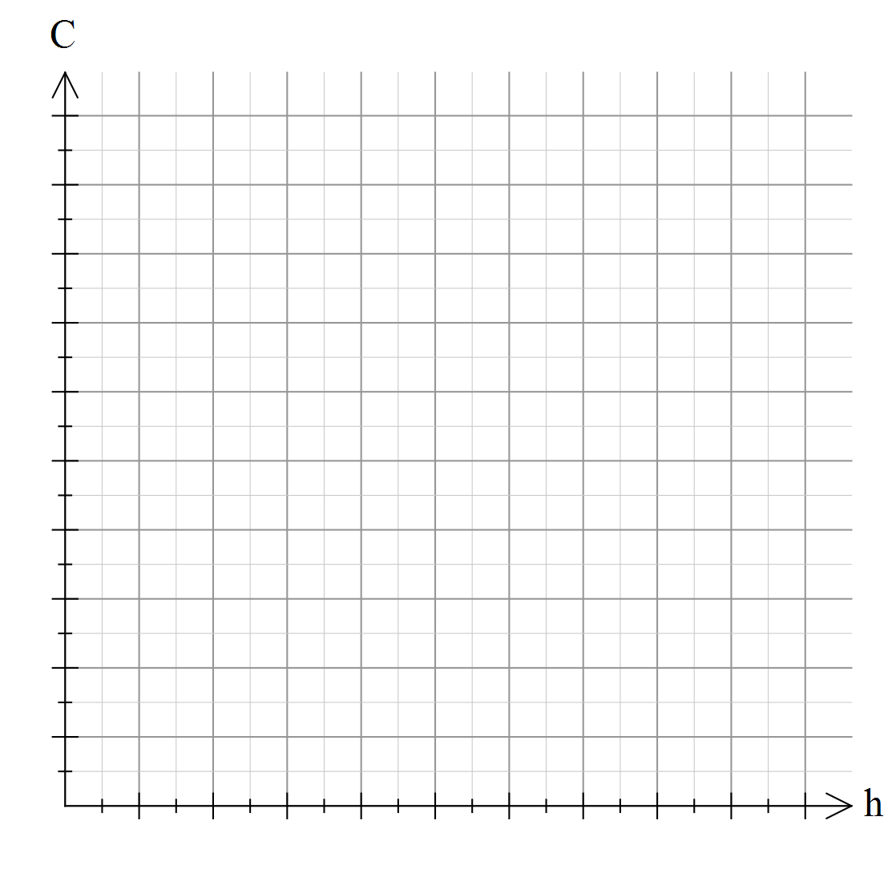

**Question 7. [3 marks]**

Consider the chart below showing the cost of an international phone call from

Australia to Belgium.

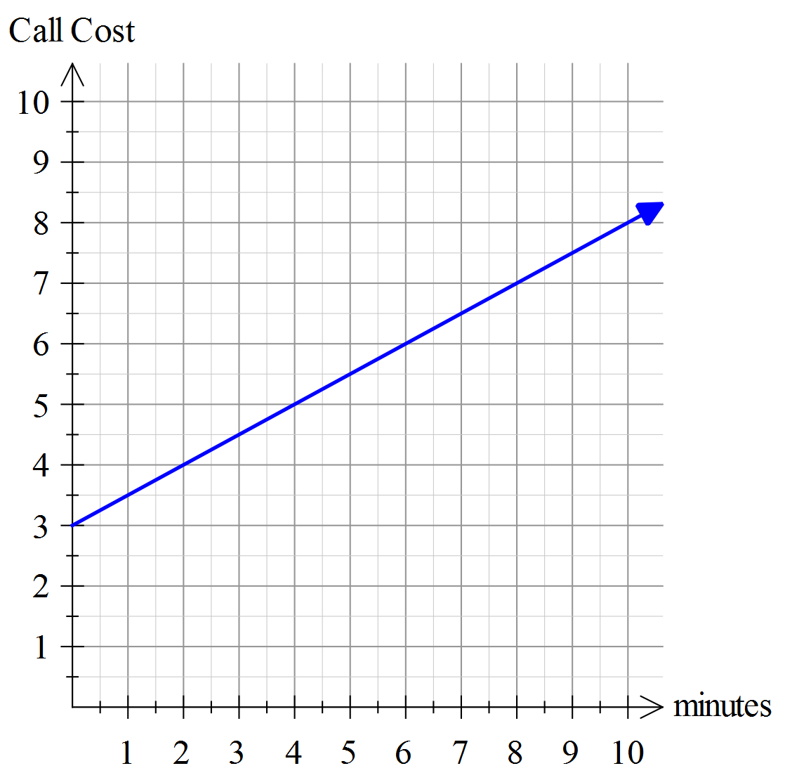

a) What is the gradient of the line?

b) What is the y-intercept of the line?

c) Describe the cost of a phone call to

Belgium using your answers from (a) & (b)

**Question 8. [4 marks]**

The entry fee to the annual Agricultural Show is charged according the patron’s age.

Use then information provided to complete the table and the step graph shown below.

|  |  |
| --- | --- |
| Ticket Prices | |
| Age (years) | Cost |
| 0 – 2 | Free |
| 3 - 11 |  |
| 12 – 17 | $10.00 |
| 18 - 54 | $14.00 |
| 55 plus |  |

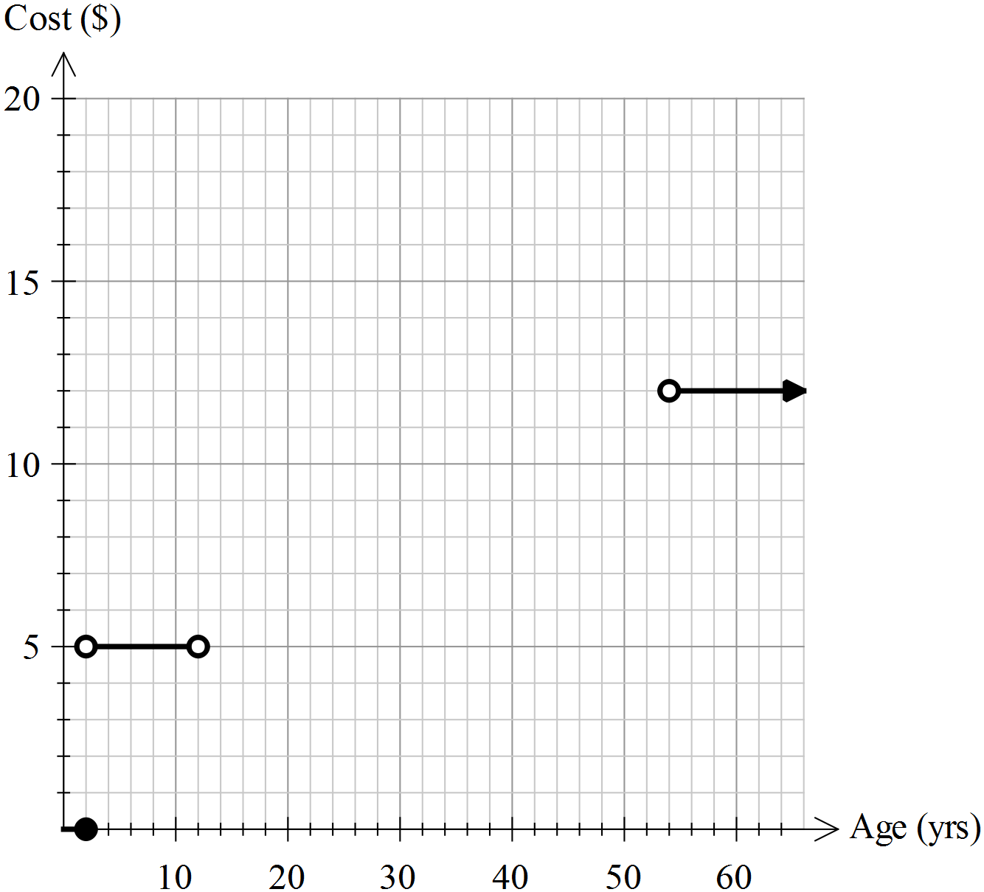

**Question 9. [6 marks]**

Write an equation for the piece wise function





 

